
Open Education

No. 78 July 20, 2019
We shouldn’t treat teachers as interchangeable widgets on a production line - Anon

A MISNOMER
Practically every day an article comes to my attention about the importance of math in our daily lives and the gap between what students learn and what they need; I also hear it regularly from grandparents and employers. Improvement in pan-Canadian and international tests do not seem to correlate with local views. The gap is referred to as a math problem; I see it as an education problem.

Math is a tool; all of us need to learn how to use it. I liken it to driving a car; we need to know a bit about cars but the real test is to integrate the automobile into our every day activities. So it is with math. Issues seem to be ones of:
- Relevance to every day living
- Transparency in reporting
- Benchmarks
- Fluency or practice
- Lack of consultation and communication

If the public perception is not accurate, the Department should inform us of the facts; if perceptions are accurate, steps should be taken to improve instruction.

LEADERSHIP CHANGE

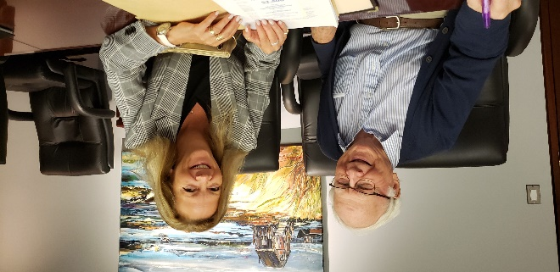
Sharon Cameron, President of Education 20/20 Inc. and Don Glendenning, Past President, discuss the agenda for an upcoming Executive meeting

EDUCATION EXPERTISE
The Sydney Morning Herald reports that Australia plans to export its “HSC and VCE” ( High School Certificate and Victorian Certificate of Education) to the “lucrative international school market.”

SACKVILLE SCHOOLS 20/20
ou may have noticed that “Sackville Schools 2020” has transitioned to the more official “Sackville 20/20”—a registered non-profit. The 20/20 represents “clear seeing and a strong vision for community supported education”

Don Glendenning, Editor
_______________________________________
Education 20/20 Inc.
PO Box 624 / 101, rue Kent, B.P. 624
Charlottetown, PEI / C1A 1M0
Email/Courriel : pei@education2020.ca URL : www.education2020.ca

